Creating a backup event with Sybase Central for Sybase 12
- Open Sybase Central from Start-Programs-Sql Anywhere 12-Administrative Tools-Sybase Central.
- Click on Connections and from the drop down choose ‘Connect with SQL Anywhere 12…’
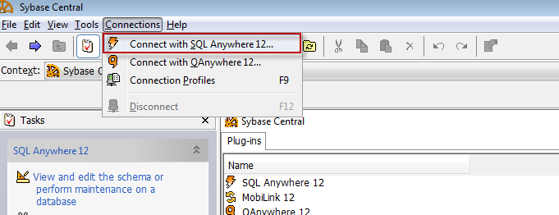
- From the ‘Connect’ screen below make sure name ‘dci’ and password are filled out. Then make sure the Data Source name is selected ‘dci_itm’ . If it is not you can browse to find it. Once all is filled out click on ‘Connect’
- From the following screen select ‘Events’
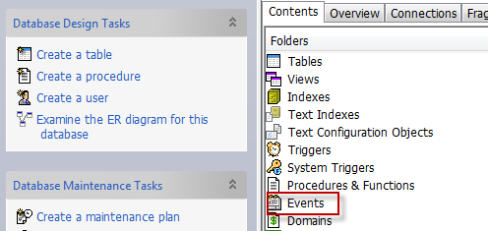
- Right click on the events screen and choose ‘New’ and then ‘Event’
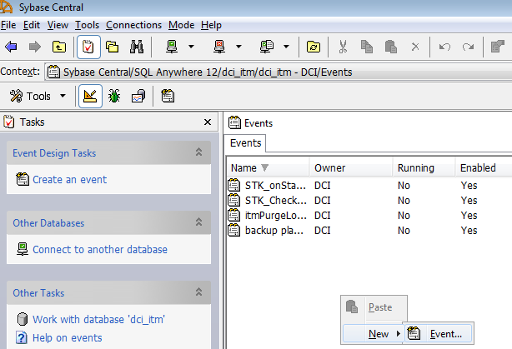
- On the next page name the event i.e. Database Backup and select ‘Next’.
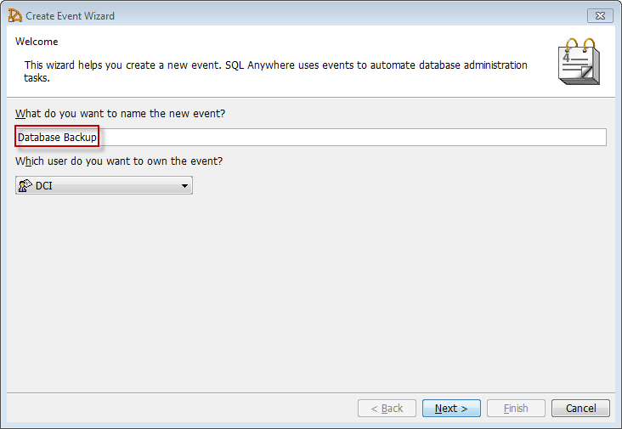
- On the next page select ‘Scheduled’ so you can schedule the time and dates of the backup.
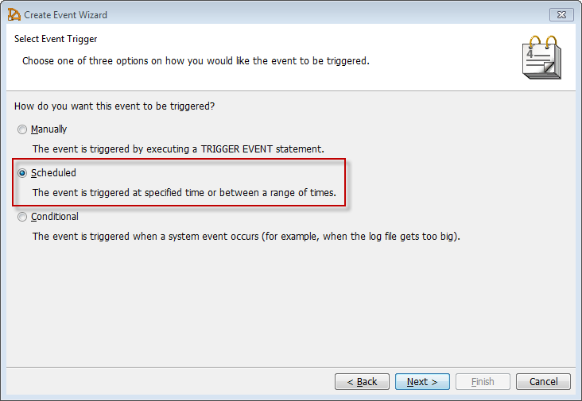

- Name the schedule for the event.
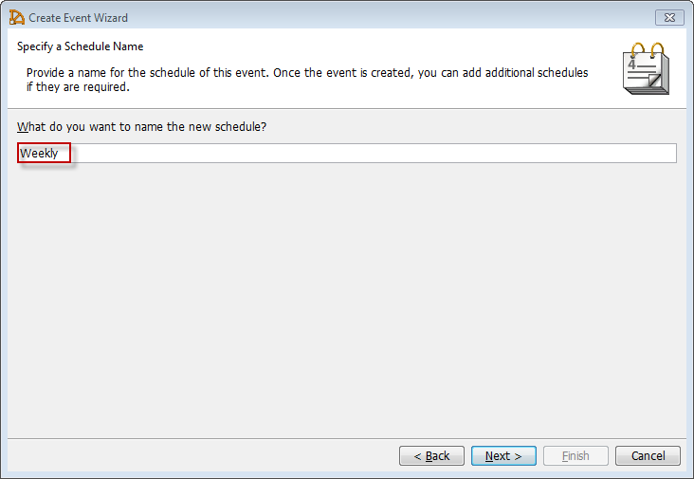
- Select time of the event.
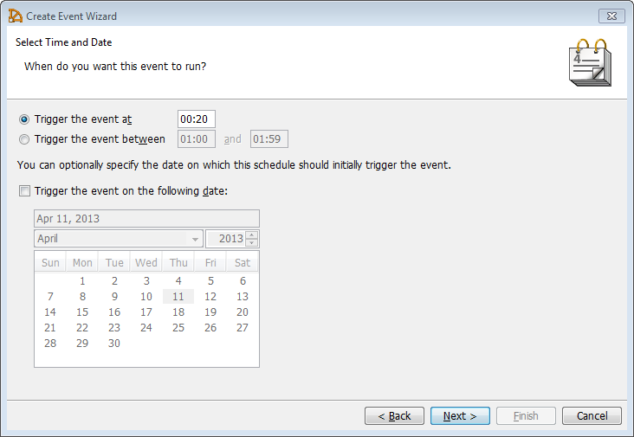

- Input the dates and occurrence of the event.
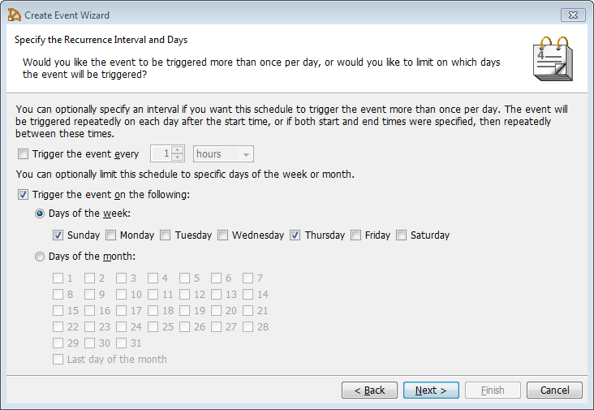
- Enable the event and hit ‘next’
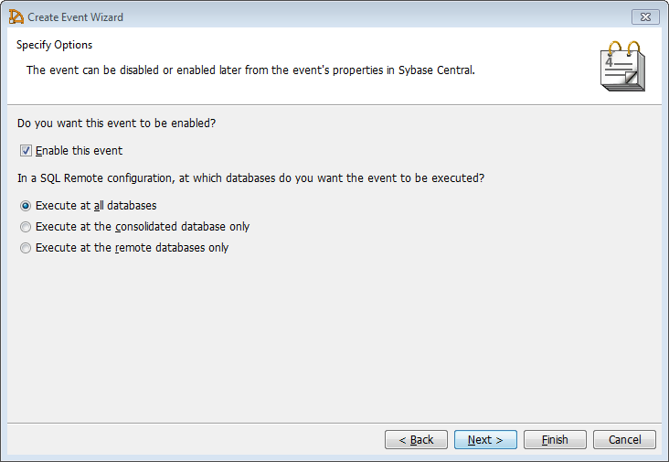
- Add comments for the event if you wish.
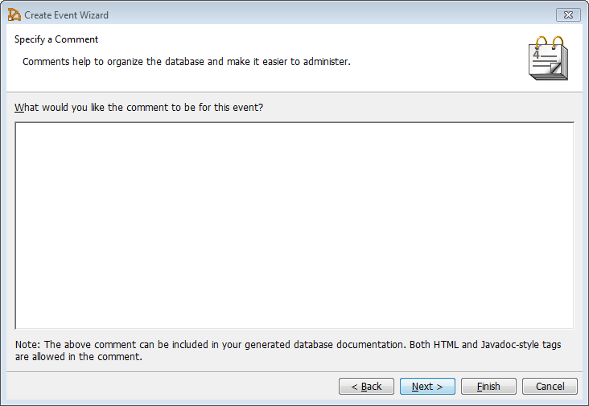
- Accept the event script
- Below is where you type in the backup command
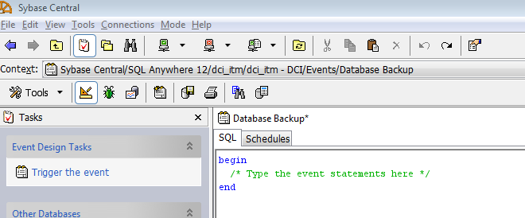
- Type in the command and click on the ‘Schedules’ tab to make sure event timing is correct

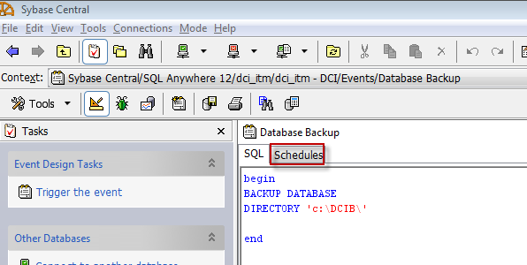

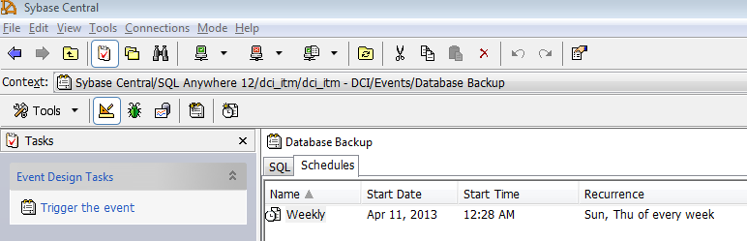
- Make sure to check to make sure the backup occurred correct when specified

